ORDER FORM
Order No.: Name of Customer: Date: ____
Hair Type: 1. % Chinese Remy Human Hair 2. % Indian Remy Human Hair3. %Malaysian Human Hair4. % European Human Hair 5. % Mongolian Human Hair 6. % Indian Remy Hair + % Chinease remy Hair
Hair Texture pattern: __________ [ ] As picture
Hair Length:
Hair Color: ____ [ ] As picture
Hair Density: [ ] 80% [ ] 100% [ ] 120% [ ] customized
Baby Hair: [ ] No [ ] Around Entire Perimeter [ ] Other
Type of Knots: [ ] General Knots [ ] Bleached Knots [ ] Other Double Knots
Hair Style: [ ] Free Style [ ] With Photo from Customer [ ] Others

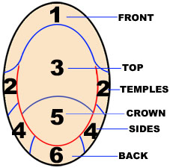  If you are getting high-lights please let me know the area that you want each color | Cap Design:  1.[ ] Lace Front Wigs(1-2-3 is lace, other area is machine made wefts)  2.Full lace wigs  [ ] With a little Stretch Lace From ear to ear no pu  [ ] With a little Stretch Lace From ear to ear with pu  [ ] Without Stretch Lace.  [ ] With Stretch Lace at crown.  3.[ ] Full thin Skin ,all head is thin skin.  4.[ ] thin skin around perimeter，lace around the head, with a little stretch lace from ear to ear  5.[ ] customized  Lace Color: [ ] dark brown [ ] brown [ ] light Brown  [ ] transparent  Lace Type: [ ] Swiss [ ] French  6.highlight: [ ] at front only [ ]throught the head [ ]streak highlight  7. [ ] two tone( )
Cap Size
[ ] Large [ ] Medium [ ] Small [ ] Customized
Head Measurements Template

1 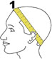 Circumference 2 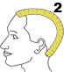 Front to Nape
3 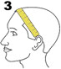 Ear to ear across forehead 4 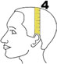 Ear to ear over top
5 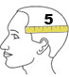 Temple to temple round back 6 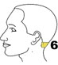 Nape of Neck

Size: 1 2 3 4 5 6 ____

Friendship Reminding:
Please make sure that you make your head measurements in this way shown in above pictures. Right measurements is very important for you to get the excellent and suitable wigs.
We are not responsible for the wrong measurements.
Other specifications or pictures:

